/n



**MANDURAH CATHOLIC COLLEGE**

### Complex numbers

### Test 1 2019

**Section One – Calculator Free**

# MATHEMATICS Specialist Unit 3

# Year 12

NAME: \_\_\_\_\_\_\_\_\_\_\_\_\_\_\_\_\_\_\_\_\_\_\_\_\_\_\_\_\_\_\_\_\_\_\_\_\_\_\_\_\_\_\_\_\_\_\_\_\_\_\_\_\_\_\_\_\_\_\_\_\_\_\_\_\_\_\_

TEACHER: \_\_\_\_\_\_\_\_\_\_\_\_\_\_\_\_\_\_\_\_\_\_\_\_\_\_\_\_\_\_\_\_\_\_\_\_\_\_\_\_\_\_\_\_\_\_\_\_\_\_\_\_\_\_\_\_\_\_\_\_\_\_\_\_\_\_\_

CALCULATOR FREE:\_\_\_\_\_\_\_/26 CALCULATOR ASSUMED\_\_\_\_\_\_/24

TOTAL: \_\_\_\_\_\_\_/50 PERCENTAGE: \_\_\_\_\_\_\_ %

**TIME ALLOWED FOR THIS PAPER**

Working time for paper: Section One: 25 minutes

Section Two: 25 minutes

Total Time = 50 minutes

**MATERIALS REQUIRED/RECOMMENDED FOR THIS PAPER**

*TO BE PROVIDED BY THE TEACHER*

This Question/Answer Booklet

SCSA Formula Sheet

*TO BE PROVIDED BY THE STUDENT*

*Standard Items:* Pens, pencils, eraser or correction tape, ruler, protractor.

**IMPORTANT NOTE TO STUDENTS**

**No other items may be taken into the classroom. It is your responsibility to ensure that you do not have any unauthorised notes or other items of a non-personal nature in the classroom. If you have any unauthorised material with you, hand it to the teacher BEFORE reading any further.**

**Instructions to Students**

1. **ALL** questions should be attempted.

2. Write your answers in the spaces provided in this Question/Answer Booklet.

3. **SHOW ALL YOUR WORKING CLEARLY**. Your working should be sufficient detail to allow your answers to be checked readily and for marks to be awarded for reasoning. Correct answers given without supporting reasoning may not be allocated full marks. Incorrect answers given without supporting reasoning cannot be allocated any marks.

4. If you repeat an answer to any question, ensure that you cancel the answers you do not wish to have marked.

5. It is recommended that you **do not use pencil**, except in diagrams.

**Question 1 [1, 1, 1 = 3 marks]**

For the complex numbers $z=1-\sqrt{3}i$    and $w=2 cis \left(\frac{π}{4}\right)$

(a) Express z in polar form, C:\Users\8476 - DComtesse\AppData\Local\Packages\Microsoft.Office.Desktop_8wekyb3d8bbwe\AC\INetCache\Content.MSO\77096151.tmp, where C:\Users\8476 - DComtesse\AppData\Local\Packages\Microsoft.Office.Desktop_8wekyb3d8bbwe\AC\INetCache\Content.MSO\84FBC087.tmp.

(b) Find expressing your answer in Cartesian form.

C:\Users\8476 - DComtesse\AppData\Local\Packages\Microsoft.Office.Desktop_8wekyb3d8bbwe\AC\INetCache\Content.MSO\8204032D.tmp

(c) Find expressing your answer in polar form.

**Question 2 [3 marks]**

Showing use of De Moivre’s theorem, express $Cos 3θ$ in terms of $Cos θ$.

**Question 3 [3, 2 = 5 marks]**

(a) Sketch the solution to $\left\{\arg\left(z\right)\right.=arg⁡(z+2-\left.2i)\right\}$

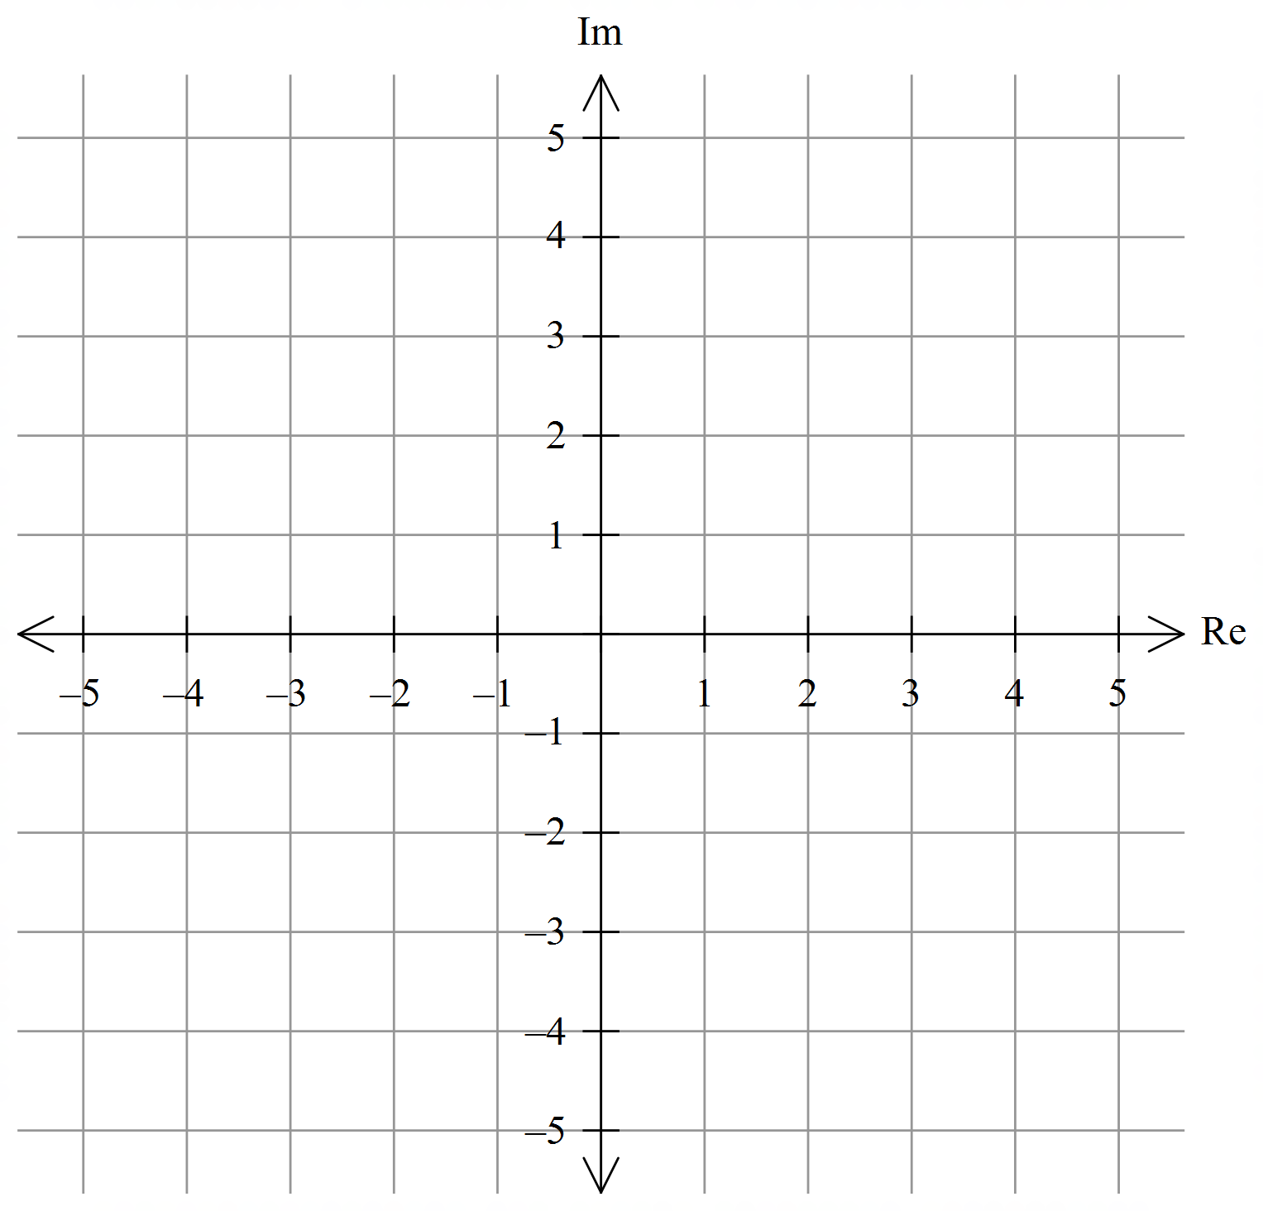

(b) Determine the conditions for a and b in $\left\{\arg\left(z\right)\right.=arg⁡(z+a+\left.bi)\right\}$ to produce infinite solutions and explain any gaps in the set of solutions.

**Question 4 [3, 4 = 7 marks]**

Sketch and shade the region in the argand plane defined by:

(a) $\left\{z\right.:\frac{π}{4}≤\arg\left(z\right)≤-\frac{π}{4}∩r ≤\left.3\right\}$



(b) $\left\{z\right.:\left|z-2+3i\right|≤\left.\left|z+1+i\right|\right\}$



**Question 5 [4 marks]**

For $\left\{z\right.:\left|z-3+3i\right|=\left.4\right\}$ determine the minimum possible value of |z| and the minimum arg(z).

**Question 6 [4 marks]**

Given that $x-1$ is a factor of $F\left(x\right)=x^{4}-6x^{3}-3x^{2}+20x-12$, show that $F\left(1\right)=0$ hence completely factorise $F(x)$.

**End of Section One**

**Additional working space**

Question number:\_\_\_\_\_\_\_\_\_\_\_



**MANDURAH CATHOLIC COLLEGE**

# Complex Numbers

# Test 1 2019

**Section 2 Calculator-Assumed**

# MATHEMATICS Specialist Unit 3

# Year 12

NAME: \_\_\_\_\_\_\_\_\_\_\_\_\_\_\_\_\_\_\_\_\_\_\_\_\_\_\_\_\_\_\_\_\_\_\_\_\_\_\_\_\_\_\_\_\_\_\_\_\_\_\_\_\_\_\_\_\_\_\_\_\_\_\_\_\_\_\_

TEACHER: \_\_\_\_\_\_\_\_\_\_\_\_\_\_\_\_\_\_\_\_\_\_\_\_\_\_\_\_\_\_\_\_\_\_\_\_\_\_\_\_\_\_\_\_\_\_\_\_\_\_\_\_\_\_\_\_\_\_\_\_\_\_\_\_\_\_\_\_

RESULT CA:\_\_\_\_\_\_\_/24

**TIME ALLOWED FOR THIS PAPER**

Working time for paper: Section 1 = 25 minutes

Section 2 = 20 minutes

Total Time = 45 minutes

**MATERIALS REQUIRED/RECOMMENDED FOR THIS PAPER**

*TO BE PROVIDED BY THE TEACHER*

This Question/Answer Booklet

Formula Sheet

*TO BE PROVIDED BY THE STUDENT*

*Standard Items:* Pens, pencils, eraser or correction tape, ruler, protractor.

*Special Items:* Scientific/CAS calculator, 1 A4 (one sided) page of notes

**IMPORTANT NOTE TO STUDENTS**

**No other items may be taken into the classroom. It is your responsibility to ensure that you do not have any unauthorised notes or other items of a non-personal nature in the classroom. If you have any unauthorised material with you, hand it to the teacher BEFORE reading any further.**

**Instructions to Students**

1. **ALL** questions should be attempted.

2. Write your answers in the spaces provided in this Question/Answer Booklet.

3. **SHOW ALL YOUR WORKING CLEARLY**. Your working should be sufficient detail to allow your answers to be checked readily and for marks to be awarded for reasoning. Correct answers given without supporting reasoning may not be allocated full marks. Incorrect answers given without supporting reasoning cannot be allocated any marks.

4. If you repeat an answer to any question, ensure that you cancel the answers you do not wish to have marked.

5. It is recommended that you **do not use pencil**, except in diagrams.

**Question 7 [2, 3 = 5 marks]**

(a) Multiplying a non-zero complex number by $\frac{1-i}{1+i}$ results in what rotation about the origin on the Argand plane?

(b) The complex number $z=a Cisθ$ and $w=b Cisα$ where $-π ≤θ,α ≤ π$ satisfy,

$$1+z+w=0$$

1, z and w form the vertices of an equilateral triangle on the Argand plane, determine the coordinates of the vertices.

**Question 8 [2, 2, 3 = 7 marks]**

Given $z=r cis θ$ is any complex number

(a) Simplify $2i\overline{z}$ into $r cis θ$ format.

(b) Determine the nature of the triangle formed by $z-r$ and explain why $θ≠0, π$.

(c) Identify the case where the triangle formed is equilateral and determine an equation for the third side, w, which fits z – r + w = 0.

**Question 9 [3 marks]**

Given that the complex number $z=a+bi$, determine a and b given $Im\left(\frac{2z+i}{z}\right)=0$ and $Re\left(\frac{2z+i}{z}\right)=10$.

**Question 10 [4, 5 = 9 marks]**

(a) Given $z^{3}=-1$ determine all solutions in $r cis θ.$

(b) Given $P\left(z\right)=Q\left(z\right).R(z)$ and $Q\left(z\right)=z^{2}-2z+5$ and $R\left(z\right)=z^{3}+1$ solve the following equation giving all answers in $a+bi; -π ≤ θ ≤ π$

$$T\left(z\right)=z^{5}-2z^{4}+5z^{3}+ z^{2}-2z+5$$

**End of Assessment**

**Additional working space**

Question number:\_\_\_\_\_\_\_\_\_\_\_